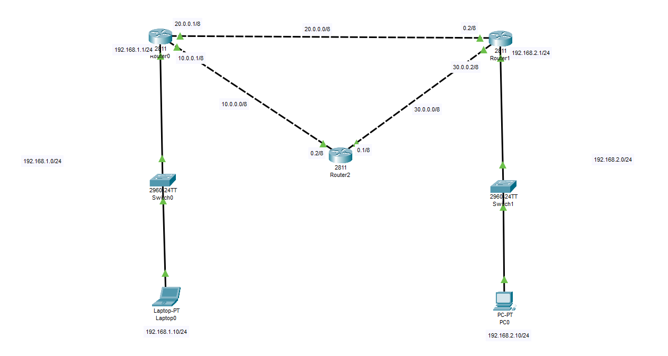

Configuring Router R0 (all interfaces):

|  |
| --- |
| Router>enable  Router#conf t  Enter configuration commands, one per line. End with CNTL/Z.  Router(config)#int fa0/0  Router(config-if)#ip add 192.168.1.1 255.255.255.0  Router(config-if)#no shut  Router(config-if)#  %LINK-5-CHANGED: Interface FastEthernet0/0, changed state to up  %LINEPROTO-5-UPDOWN: Line protocol on Interface FastEthernet0/0, changed state to up  Router(config-if)#  Router(config-if)#exit  Router(config)#int fa0/1  Router(config-if)#ip add 10.0.0.1 255.0.0.0  Router(config-if)#no shut  Router(config-if)#exit  Router(config)#int fa1/0  Router(config-if)#ip add 20.0.0.1 255.0.0.0  Router(config-if)#no shut  Router(config-if)#  %LINK-5-CHANGED: Interface FastEthernet1/0, changed state to up  Router(config-if)# |

Configuring Router R1 (all interfaces):

|  |
| --- |
| Router>en  Router#conf t  Enter configuration commands, one per line. End with CNTL/Z.  Router(config)#int fa1/0  Router(config-if)#ip add 20.0.0.2 255.0.0.0  Router(config-if)#no shut  Router(config-if)#  %LINK-5-CHANGED: Interface FastEthernet1/0, changed state to up  %LINEPROTO-5-UPDOWN: Line protocol on Interface FastEthernet1/0, changed state to up  Router(config-if)#exit  Router(config)#int fa0/1  Router(config-if)#ip add 30.0.0.2 255.0.0.0  Router(config-if)#no shut  Router(config-if)#exit  Router(config)#int fa0/0  Router(config-if)#ip add 192.168.2.1 255.255.255.0  Router(config-if)#no shut  Router(config-if)# |

Configuring Router R2 (all interfaces):

|  |
| --- |
| Router>en  Router#conf t  Enter configuration commands, one per line. End with CNTL/Z.  Router(config)#int fa0/0  Router(config-if)#ip add 10.0.0.2 255.0.0.0  Router(config-if)#no shut  Router(config-if)#exit  Router(config)#int fa0/1  Router(config-if)#ip add 30.0.0.1 255.0.0.0  Router(config-if)#no shut  Router(config-if)# |

Configuring OSPF on Router R0:

|  |
| --- |
| Router>en  Router#conf t  Enter configuration commands, one per line. End with CNTL/Z.  Router(config)#  Router(config)#router ospf 1  Router(config-router)#network 192.168.1.0 0.0.0.255 area 0  Router(config-router)#network 10.0.0.0 0.255.255.255 area 0  Router(config-router)#network 20.0.0.0 0.255.255.255 area 0  Router(config-router)#exit  Router(config)#^Z  Router#  %SYS-5-CONFIG_I: Configured from console by console  Router#wr  Building configuration...  [OK]  Router# |

Configuring OSPF on Router R1:

|  |
| --- |
| Router>en  Router#conf t  Enter configuration commands, one per line. End with CNTL/Z.  Router(config)#router ospf 1  Router(config-router)#network 20.0.0.0 0.255.255.255 area 0  Router(config-router)#netowrk 30.0  00:31:03: %OSPF-5-ADJCHG: Process 1, Nbr 192.168.1.1 on FastEthernet1/0 from LOADING to FULL, Loading Done  ^  % Invalid input detected at '^' marker.  Router(config-router)#network 30.0.0.0 0.255.255.255 area 0  Router(config-router)#network 192.168.2.0 0.0.0.255 area 0  Router(config-router)#exit  Router(config)#^Z  Router#  %SYS-5-CONFIG_I: Configured from console by console  Router#wr  Building configuration...  [OK]  Router# |

Configuring OSPF on Router R2:

|  |
| --- |
| Router>en  Router#conf t  Enter configuration commands, one per line. End with CNTL/Z.  Router(config)#router ospf 1  Router(config-router)#network 10.0.0.0 0.255.255.255 area 0  Router(config-router)#network 30.0.0.0  00:35:58: %OSPF-5-ADJCHG: Process 1, Nbr 192.168.1.1 on FastEthernet0/0 from LOADING to FULL, Loading Done  % Incomplete command.  Router(config-router)#network 30.0.0.0 0.255.255.255 area 0  Router(config-router)#exit  Router(config)#^Z  Router#  %SYS-5-CONFIG_I: Configured from console by console  Router#wr  Building configuration...  [OK] |